Interval Notation:

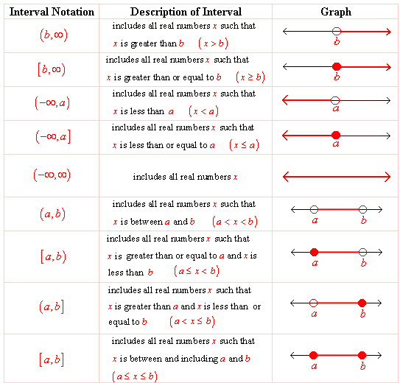

Example:

Solution:
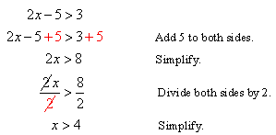

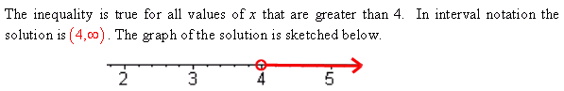

Example:

Solution:
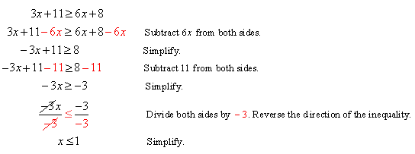

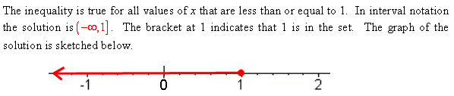

Example:
Solution:
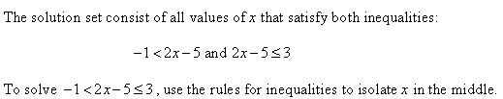

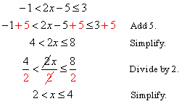

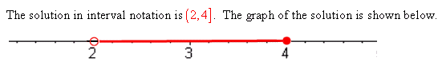

Additional Example 1:

Solution:
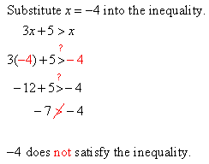

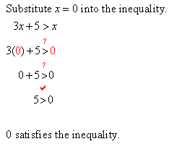

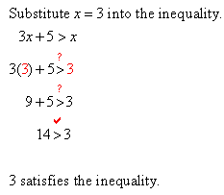

Additional Example 2:
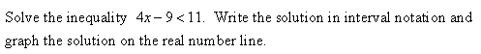

Solution:
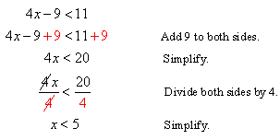

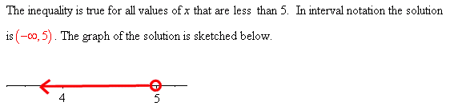

Additional Example 3:
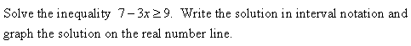

Solution:
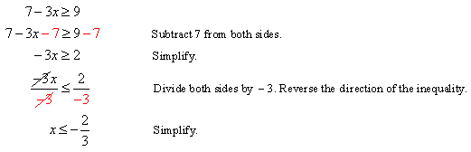

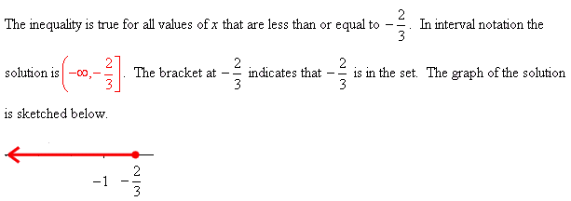

Additional Example 4:

Solution:
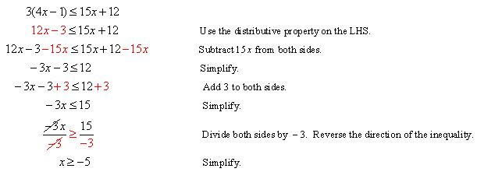
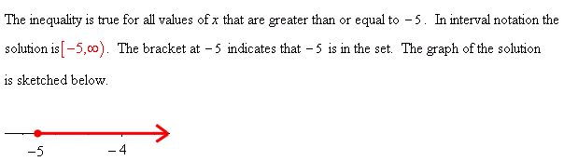

Additional Example 5:
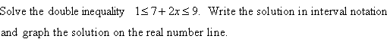

Solution:
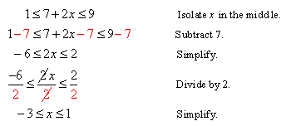

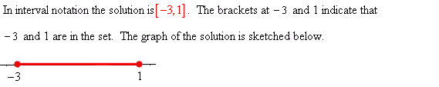

Additional Example 6:
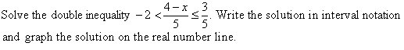

Solution:
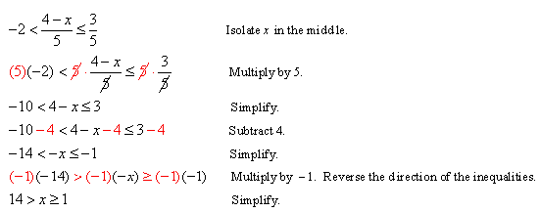

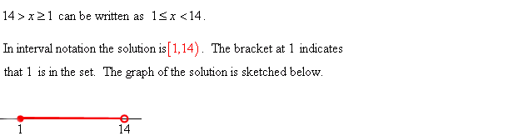

Additional Example 7:
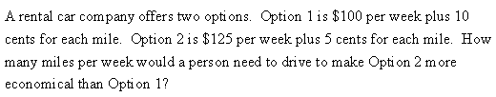

Solution:
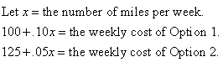

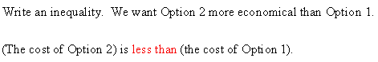

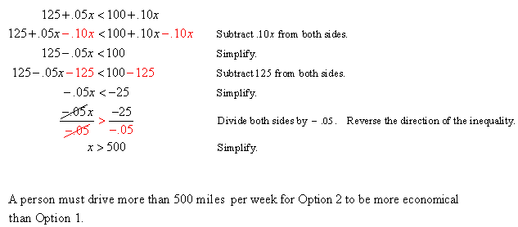

For each of the following inequalities:
(a) Write the inequality algebraically.
(b) Graph the inequality on the real number line.
(c) Write the inequality in interval notation.

- x is greater than 5.
- x is less than 4.
- x is less than or equal to 3.
- x is greater than or equal to 7.
- x is not equal to 2.
- x is not equal to .
- x is less than
- x is greater than .
- x is greater than or equal to .
- x is less than or equal to .
- x is not equal to .
- x is not equal to 3.
- x is not equal to 2 and x is not equal to 7.
- x is not equal to and x is not equal to 0.

Write each of the following inequalities in interval notation.

- $$x>3$$
- $$x≥−5$$
- $$x≤−2$$
- $$x<7$$
- $$3<x≤5$$
- $$−7≤x≤2$$
Write each of the following inequalities in interval notation.

Given the set $S=\left\{ 2, 4, −3, \frac{1}{3} \right\}$, use substitution to determine which of the elements of S satisfy each of the following inequalities.

- $$2x+5≤\text{10}$$
- $$4x−2>−\text{14}$$
- $−2x+1>−7$
- $$−3x+1≥0$$
- $$x^{2}+1<\text{10}$$
- $$\frac{1}{x}≤\frac{2}{5}$$

For each of the following inequalities:
- Solve the inequality.
- Graph the solution on the real number line.
- Write the solution in interval notation.

- $2x<\text{10}$
- $$3x≥\text{24}$$
- $$−5x≥\text{30}$$
- $$−4x<\text{40}$$
- $$2x−5≥−\text{11}$$
- $$3x+4≤−\text{17}$$
- $$8−3x>\text{20}$$
- $$\text{10}−x>0$$
- $$4x−\text{11}<7x+4$$
- $$5−9x≤3x−7$$
- $$\text{10}x−7≥2x+6$$
- $$8−4x<6−5x$$
- $$5−8x≥4x+1$$
- $$x+\text{10}≥8x−9$$
- $$−3(4+5x)<−2(7−x)$$
- $$−4(3−2x)≤−(x+\text{20})$$
- $$\frac{5}{6}−\frac{1}{3}x≤\frac{1}{2}(x+5)$$
- $$\frac{2}{5}\left(x+\frac{1}{2}\right)>−\frac{1}{3}\left(\text{10}−x\right)$$
- $$−\text{10}≤3x+2<8$$
- $$−9<2x−3<\text{13}$$
- $$−4≤3−7x≤\text{17}$$
- $$−\text{19}<5−4x≤−3$$
- $$\frac{2}{3}<\frac{3x−\text{10}}{\text{15}}<\frac{4}{5}$$
- $$\frac{3}{4}>\frac{5−2x}{6}>−\frac{5}{3}$$

Which of the following inequalities can never be true?

- (a) $5≤x≤9$
(b) $9≤x≤5$
(c) $−3<x≤7$
(d) $−5≥x>−3$

